**IOT & Cyber Security**

~Week 10-11~

IOT Seminar Report

**Introduction:**

In the last week of December 2022, we had a seminar about IoT by **Babak Reihani** who has been professional in this field for so long. His company provides smart home solutions. He brought some products to the seminar to show us how they work and what they do. At the end of the presentation, we are asked to create a brief report about the seminar. This report simply includes the important points of the seminar we attended.

**What is IOT? Why do we need it?**

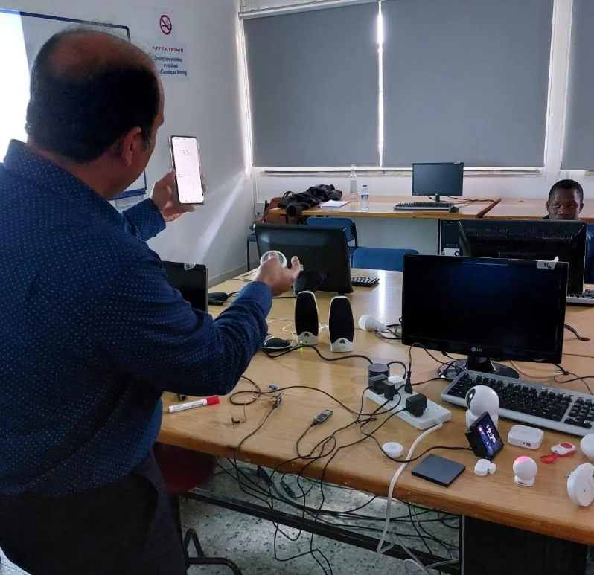The Internet of Things (IoT) refers to the connection of devices (other than typical laptops and smartphones) to the internet, allowing them to send and receive data. These devices can include everyday objects like appliances, cars, and home security systems, as well as industrial equipment like factory machines and farm sensors. IOT has the potential to revolutionize a wide range of industries by making it possible to automate and optimize various processes. For example, in manufacturing, IoT can be used to monitor equipment performance and identify maintenance needs, improving efficiency and reducing downtime. In agriculture, IoT can be used to monitor soil moisture and temperature, allowing farmers to optimize irrigation and fertilization. In transportation, IoT can be used to track the location and condition of vehicles, improving logistics and reducing fuel consumption.

IoT is also being used to improve public services, such as traffic management and waste management. For example, sensors can be used to monitor traffic patterns and optimize the timing of traffic lights, reducing congestion and improving air quality. Similarly, sensors can be used to monitor the level of trash in a bin and schedule pickups only when necessary, saving resources and reducing pollution.

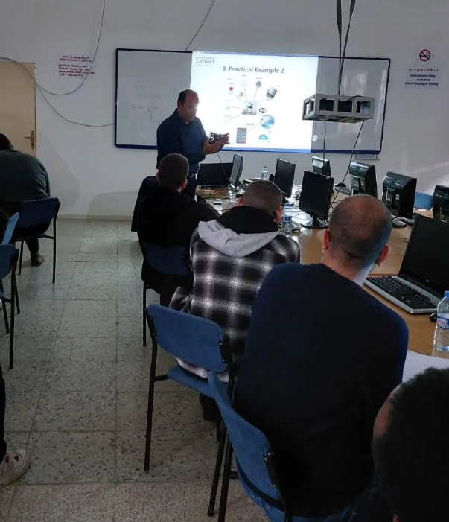Overall, the main benefits of IoT are increased efficiency, improved decision-making, and enhanced automation. However, as with any new technology, there are also potential concerns around security and privacy. It is important to carefully consider these issues and implement appropriate safeguards when implementing IoT solutions.

**Revolution of IOT industry:**

The concept of the Internet of Things (IoT) dates to the late 1990s, when researchers and technology companies first started exploring the idea of connecting everyday objects to the internet. However, it wasn't until the early 2010s that the term "Internet of Things" became widely used and the IoT industry began to take off. Here are some key milestones in the development of the IoT industry:

* **1999:** Kevin Ashton, a British technology pioneer, coins the term "Internet of Things" in a presentation about RFID (radio-frequency identification) technology.
* **2005:** The number of connected devices exceeds the number of people on earth.
* **2009:** The first "smart" home appliances, such as internet-connected refrigerators and washing machines, become available.
* **2010:** The term "Internet of Things" becomes widely used and the IoT industry begins to grow rapidly.
* **2012:** The number of connected devices surpasses 10 billion.
* **2014:** IoT becomes a buzzword and major technology companies, such as Apple, Google, and Microsoft, start investing heavily in IoT.
* **2016:** The number of connected devices surpasses 20 billion.
* **2018:** The number of connected devices surpasses 30 billion.
* **2020:** The COVID-19 pandemic accelerates the adoption of IoT in various industries, such as healthcare and logistics, as businesses seek to increase efficiency and reduce the need for physical contact.

Today, the IoT industry is still in its early stages and is expected to continue to grow rapidly in the coming years. It is estimated that there will be over 75 billion connected devices by 2025, with the market for IoT solutions expected to exceed $1 trillion.

**IOT in Smart Home Industry:**

The Internet of Things (IoT) is being used extensively in the smart home industry to allow homeowners to control and monitor various aspects of their home remotely. Some common examples of IoT applications in the smart home industry include:

* **Smart thermostats:** These devices allow homeowners to control the temperature of their home remotely, using a smartphone app or a web browser. They can also learn a homeowner's preferred temperatures and create a schedule to optimize energy usage.
* **Smart lighting:** IoT-enabled lighting systems allow homeowners to control the brightness and color of their lights remotely, using a smartphone app or a voice assistant. They can also be set to turn on and off automatically, based on a schedule or in response to other triggers.
* **Smart appliances:** Many appliances, such as refrigerators, ovens, and washing machines, now come with IoT capabilities that allow them to be controlled and monitored remotely. For example, a homeowner can start their washing machine remotely, or receive an alert if their refrigerator door has been left open.
* **Smart security:** IoT-enabled security systems can include sensors to detect movement, door and window sensors, and cameras that can be accessed remotely. These systems can alert homeowners to any potential threats and allow them to act, such as calling the authorities or activating an alarm.

Overall, the use of IoT in the smart home industry has the potential to increase convenience and security for homeowners, as well as to optimize energy usage and save money on utility bills.

17330118 – Mustafa Guner